Design Improvement for a Coaxial Cable Connector using Six Sigma

Dr.Erick Jones  University of Nebraska- Lincoln. | Saravana Palanisamy  University of Nebraska- Lincoln, U.S.A

Jon Sullivan
Centurion Wireless Technologies, Lincoln, NE

Abstract

Among the electronics industries the cellular industry has seen a tremendous growth in market as well as technology in the last decade. The shrinking size of the mobile phones and the continuous need for new models is only possible by the growth of new technologies to provide cost effective solutions and stay abreast in the market. The coaxial cable connector, which serves as a pipe between the antenna and the circuit board was found to have a potential for improvement. This project was aimed at simplifying the design of the coaxial cable connector, having in mind the ease of assembly and minimization of the cost. Being a design from scratch, the principles of DFSS (Design for Six Sigma) were implemented to get a quality product from the design stage. The CDOV (Conceptualize, Design, Optimize, Verify) cycle was chosen for its simplicity and implemented for this project.

Introduction:
In the present century, new technologies are developed and improved. These technologies eventually become obsolete for the need of more advanced technologies. In this dynamically changing world, product cycles are expected to last for just a few months. To meet these demanding requirements product developers have to develop products in the shortest amount of time that are safe, reliable, and competitive.
Many philosophies have been developed to assist companies in developing technologies and competing in the Global market. Six Sigma is one such successful methodology which is popular in the recent years. Six Sigma is a rigorous and disciplined methodology that uses data and statistical analysis to measure and improve a company's operational performance by identifying and eliminating "defects" in manufacturing and service-related processes.
The roadmap has always been an important part of Six Sigma. It lays out the thought process for teams and leaders, and distinguishes the methodology from a parade of tools. Six Sigma clearly lays down two different road maps DMAIC and DMADV for process improvement and product development. This makes sense as DMAIC brings rapid improvement to existing processes – quickly returning significant dollars to the bottom line whereas DFSS often develops in connection with technology development and product commercialization. In a world where "innovate and design" are naturally separated from "improvement work," two roadmaps may work just fine. In many real-world cases, though, design is often interwoven with existing products and processes, and improvement often means revisiting fundamental design.



The quality challenge
As a rule, design engineering has lagged behind the shop floor in awareness of product and process quality. Unfortunately, very real costs are associated with inattention to design quality. If errors or omissions in design data are not addressed early, more costly changes are required later in the product development process (see Figure 1).
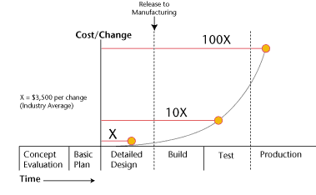

Figure 1: Cost of Changes¹

Centurion is a leading global supplier of custom-designed and manufactured antenna and power products for wireless handsets, data devices and networks. The coaxial cable connector, serves as a pipe between the antenna and the circuit board, and transmits the electronic wave signals into the circuit board. The assembly time for this connector was found to be considerably large and also in required special crimping apparatus.

Every year the global electronics industry consumes around 40 million coaxial cable connectors. Centurion being a solution provider in the antenna development segment well fits to provide a better solution in the connectors for the antennas. This would provide clearly a breakthrough in two areas. One is by equipping its customers with a competitive edge and the second by opening up a new segment for Centurion in the existing market.

Define Phase:

The high sub assembly time and the cost of the coaxial cable connector, faced by the internal/external customers, needs to be reduced. With the advent of micro film and thin metal antennas the assembly and production time for these products have gone down drastically. The integration of various parts have made the front and middle deck assembly to be easy and quick. The assembly time for the coax cable connectors alone was remained high which in turn kept the overall assembly time to be higher.
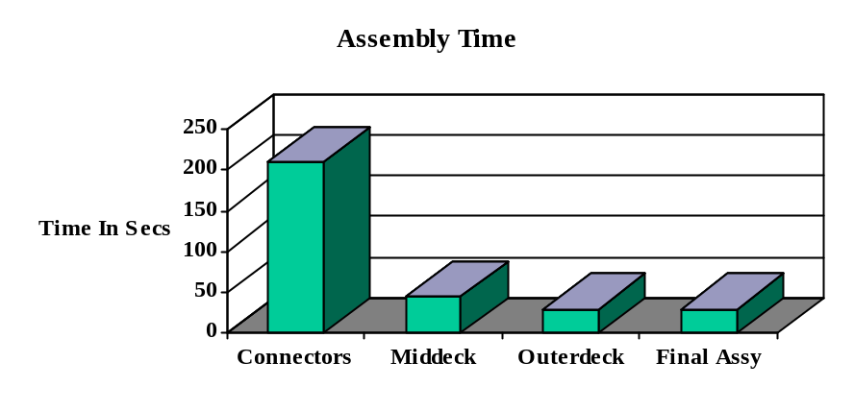 An analysis on the time taken for assembly is shown in fig1.

Measure phase:

The Measure phase identifies the key internal processes that influence critical-to-quality deliverables, metrics, or requirements (CTQs), and measures the defects generated relative to these identified CTQs.

The existing connector consists of 8 different parts and needs a special preparation of the wire and sub assembly before the whole assembly fits together. The figure 2.1 shows the existing connector with the male and female parts. Process maps as shown in fig2 were generated to determine the time consumed by each process in the assembly.

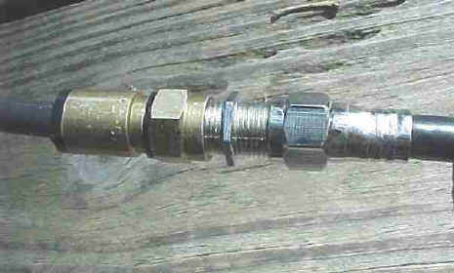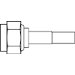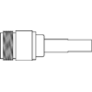
Fig 2.1. RF Connector N-Male N-Female

Process Maps

N-Male
Mechanical Crimping
Assemble male components onto the wire
Assemble female components onto the wire
Mechanical Crimping
Prepare the wire
N-Female
Prepare the wire
Time :30 secs *2
Time: 30 secs *2
Time: 30 secs *2
Final assembly
Time: 30 secs
Fig 2.2 Process Map for the assembly of Coaxial cable Connector

All processes can be viewed as a series of inputs or factors (x's) contributing to the output (Y). In other words, every process can be expressed in terms of the mathematical equation Y=f(x), where Y is a function of x [3]. In this case, example Y is the assembly time, and the x's were the various factors contributing to it. The next step was to identify all the factors (x's) potentially impacting the assembly time (Y) by completing QFD [6] as shown in Fig. 3.

KPOVS  KPIVS | Assembly Time | M/c Required | Cost of Assembly | Effect | Rank
No. of parts | 10 | - | 8 | 164 | III
Wire preparation | 5 | 5 | 3 | 139 | II
Design | 10 | 8 | 5 | 238 | I
Metal crimping | 9 | 7 | 6 | 196 | IV
Fig.3 Quality Functional Deployment Matrix
3.3 Analyze:
The fishbone diagram was a useful technique in helping team members articulate all the possible contributors to waste generation versus the few that typically come to mind. Completion of a fishbone diagram was also essential in identifying all the potential contributors to process variations - a fundamental principle of the Six Sigma approach.
Fig.4 Cause and Effect Diagram
Wire preparation
Tools required
Design
Number of parts
Micro size parts
Connector Sub assembly
Wire tip
Metal Crimping
Machines
Assembly Time
The analysis of the fish bone here said that most of the constraints are generated due to the existing design of the connector. And also previous experience said any attempts to improve the other characteristics without changing the basic design is going to cost more for any improvements. Thus it was decided to treat the problem as a DFSS problem and come up with a radically new design for the connector.

Conceptualize:
Any design needs an understanding on the basic requirements of the customer. The "voice of the customer" is a process used to capture the requirements/feedback from the customer (internal or external) to provide the customers with the best in class service/product quality. This process is all about being proactive and constantly innovative to capture the changing requirements of the customers with time. The voice of customer table provided below shows the basic requirement identification for this project.

Voice of the Customer | Key Customer Issues | Critical Customer Requirement
What does the customer want from us? | We need to identify  the issue(s) that prevent  us from satisfying our customers. | We should summarize  key issues and translate them into specific and measurable requirements
Less Labor Intensive | Wire prep.,  Connector sub Assy | Less parts,  Easy Assembly
Quick Assembly | Wire prep.,  Need for external M/c | Less parts,  Press fit (avoid ext M/c)
Cheap | Gold plating,  More parts | Cheap material,  Less parts
Low Assembly cost | Metal crimping M/c,  Labor intensive assy | Auto Insulation removal,  Few parts, Easy Assy procedures

Table 1. Voice of Customer table

Design
Thus the voice of customer table transformed the raw requirements into critical customer requirement specification. In short the design intent can be surmised as a connector with fewer parts, ease of assembly like press fit, made of cheaper material, with auto insulation removal system and with easy assembling procedures.

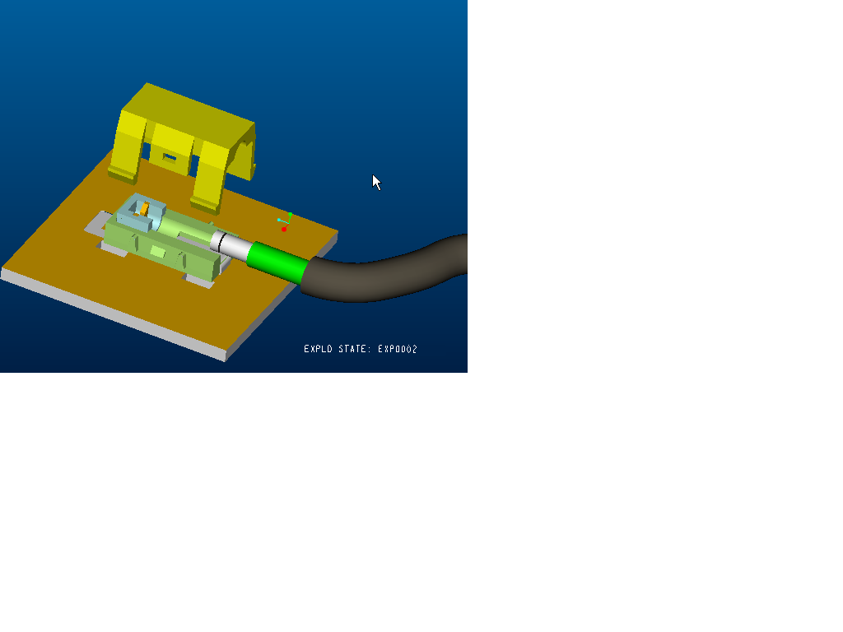
Fig3. New design for the coaxial cable connector (patent pending)

Fig 3 shows the radically new design for the coaxial cable connector generated based on the requirements generated in the design phase. It consists basically of three plastic molded parts, the top part, base part and the insulator. The primary contact in the insulator establishes contact between the core cable to the circuit board. The secondary contact at the end of the base grounds the wire.
The top part snap fits into the base part, the sub assembly of it needs to be prepared before the final assembly snap fits into the circuit board. The wire needs to be prepared in this type of connector also but the other part of the sub assembly can be manually done without the need for any external machines and done quickly.
To optimize the design, 3 different design alternatives were arrived with and a puch analysis was carried out. The pugh matrix is a tool used to facilitate a disciplined, team-based process for concept generation and selection . Several concepts are evaluated according to their strengths and weaknesses against a reference concept called the datum (base concept). The datum is the best current concept at each iteration of the matrix.
The pugh matrix allows you to
1.Compare different concepts
2. Create strong alternative concepts from weaker concepts
3. Arrive at an optimum concept that may be a hybrid of the best of other concepts
The pugh matrix encourages comparison of several different concepts against a base concept,creating stronger concepts and eliminating weaker ones until an optimal concept finally is reached. Also, the pugh matrix is useful because it does not require a great amount of quantitative data on the design concepts, which generally is not available at this point in the process.
Criteria | A | B | C
Ease of Grounding | - | + | +
Ease of Assembly | + | + | +
Manufacturability | - | + | +
Aesthetics | 0 | 0 | 0
Cost Effective | - | - | +
Sum of + | 1 | 3 | 4
Sum of 0 | 1 | 1 | 1
Sum of - | 3 | 1 | 0
Rank | 3 | 2 | 1
Continue | no | yes | yes

Table 2 Pugh analysis for design alternatives
Optimize:
Item  function | Potential failure mode | Potential effects of failure | Sev | Occur | Detect | Potential cause of failure | Current design control | Recommended action
Primary contact | Improper insulation displacement | Loss of connection | 10 | 4 | 1 | Improper assy;  Contact not placed properly or not sharp | X,y,z directional resistance with positive stops | Tighter tolerance on knife edges
Secondary contact | Drop off | Loss of connection | 10 | 4 | 1 | Loss of spring action;  Improper assy | Material with high stiffness; positive lock | Positive y direction arrest
Primary contact | Not touching the circuit board | Loss of connection | 10 | 2 | 1 | Loss of spring action;  Improper assy | Tighter tolerances;  Material with high stiffness | Tighter tolernace on primary contact
Wire | Drop off | Loss of connection | 10 | 2 | 1 | Improper assembly | Positive push from top part | Postive arrest of wire from slipping
In order to optimize the selected design a design FMEA is conducted and the results
Verify

The design was validated by creating a prototype of 10:1 size using a compatible material. The prototype was tested for its mechanical and functional behavior.

Refrences

- http://www.isixsigma.com/library/content/c020225a.asp
- Design for Six Sigma, C.M.Creveling, J.L.Slutsky
- Six Sigma Fundamentals, stamatis
- Design for Six Sigma, Kai Yang, Basem el haik
- Design for Six Sigma, Greg Brue
- Statistical Quality Control, Douglas Montgomery
- Quality control and Industrial statistics, Duncan

